Steps for Creating an Application in SalesForce.com using Apex programming Language.

Step No 1: Create new org: <https://developer.salesforce.com/signup>

Step No 2: After signup, login using following URL <https://login.salesforce.com/>

Step No 3: Login Page (Enter your credential to login)

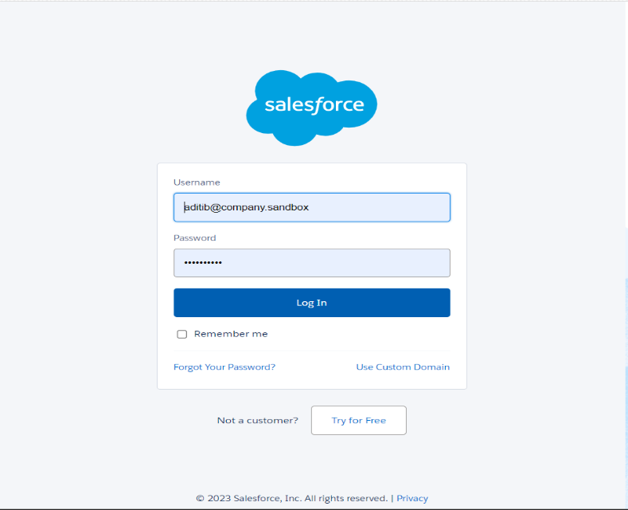

1. Open Developer Console

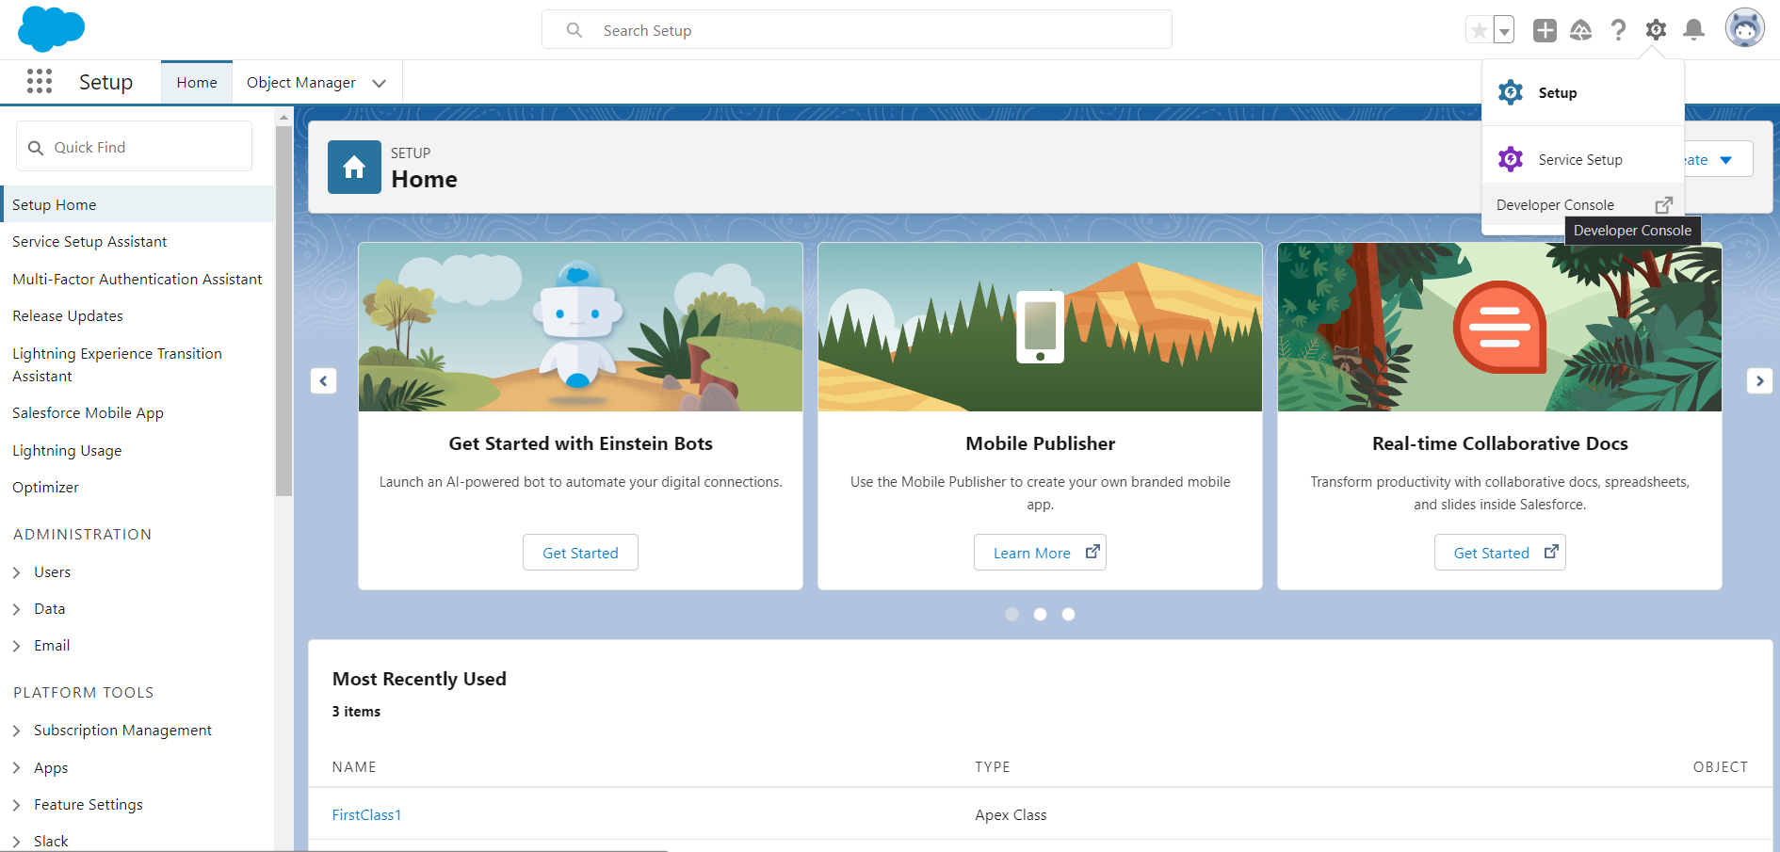

2. File ---> New ---> Select Apex Class

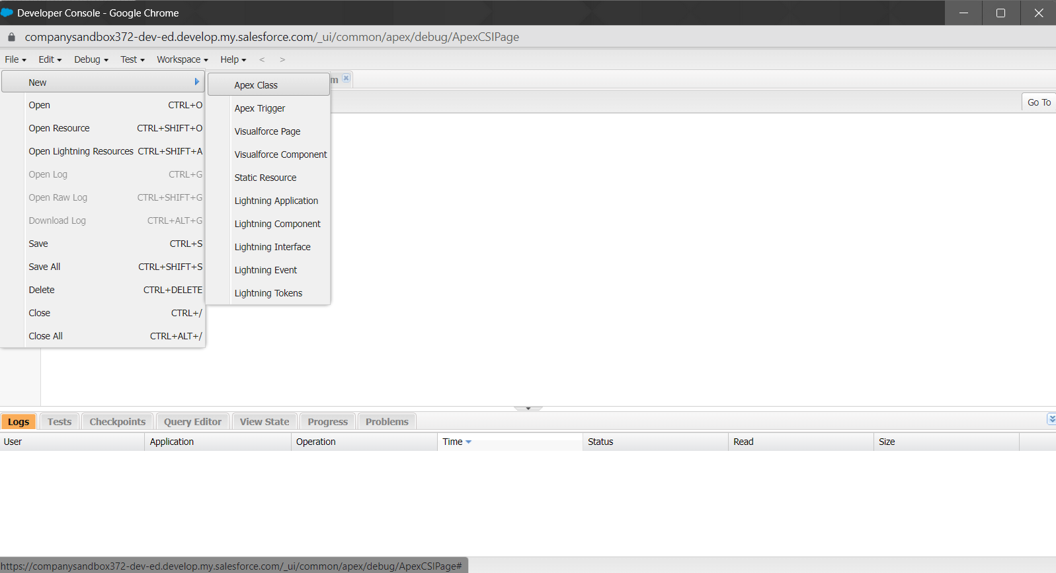

3. Type below mentioned code

public class FirstClass1 {

public static void firstMethod() {

System.debug('WELCOME TO METIOE NASHIK');

}

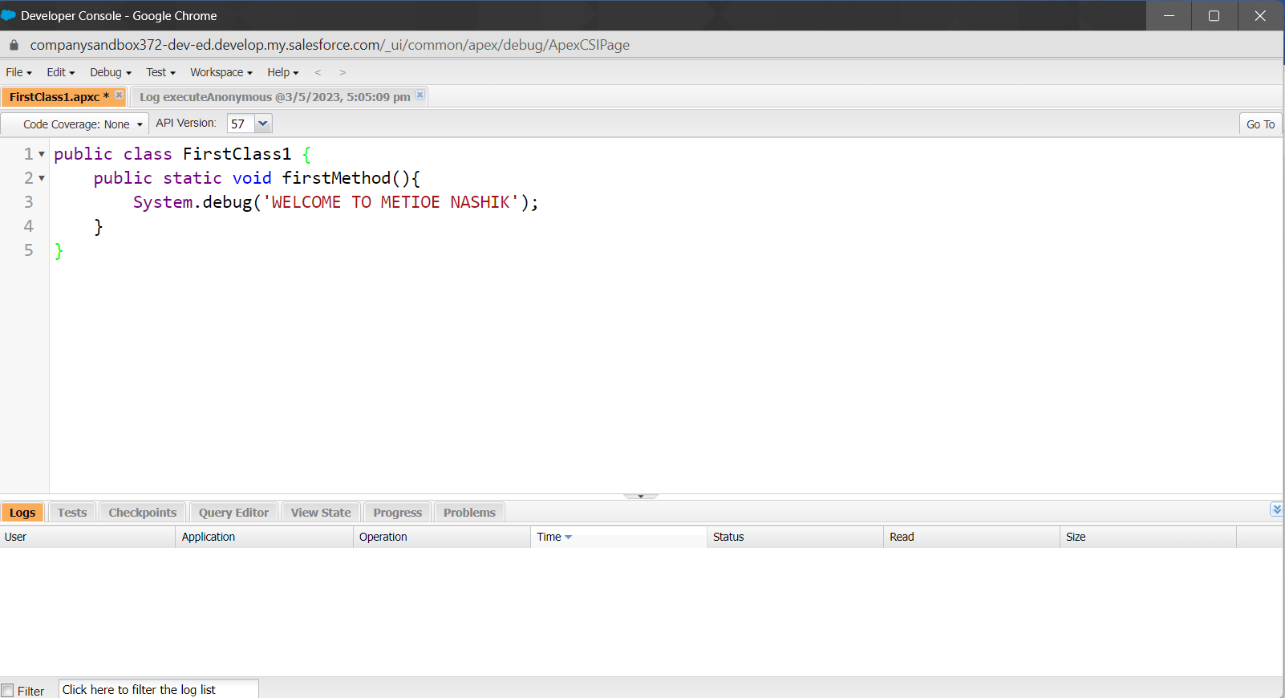 }

Note : you can write any code as application

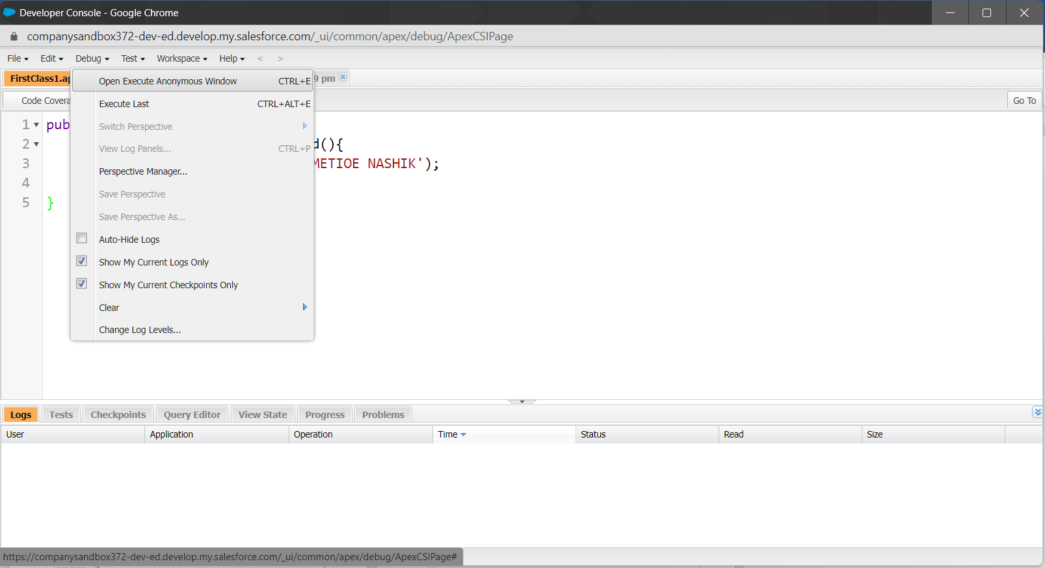4. Click on Debug ---> Open Execute Acronymous Window

5. Type below code(Apex Code)

FirstClass1.firstMethod();

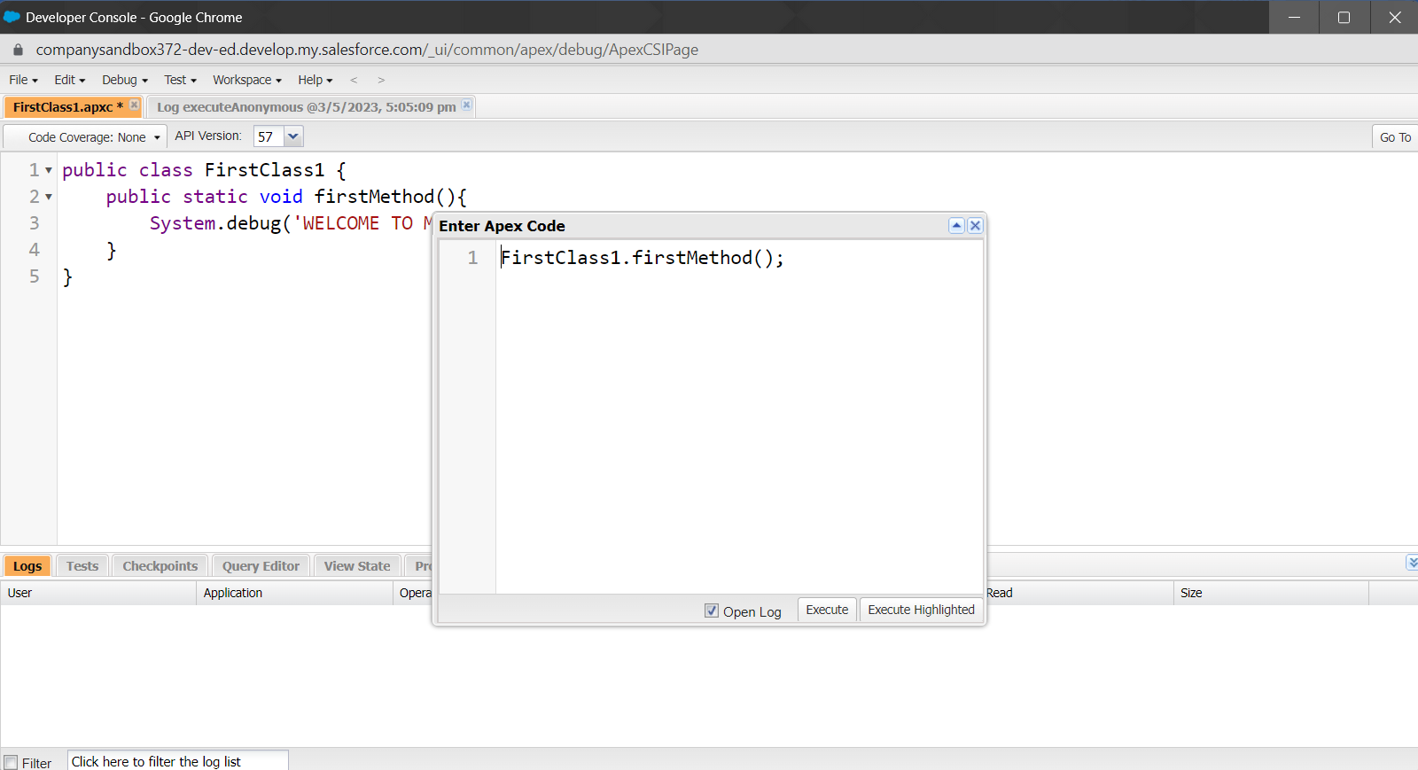

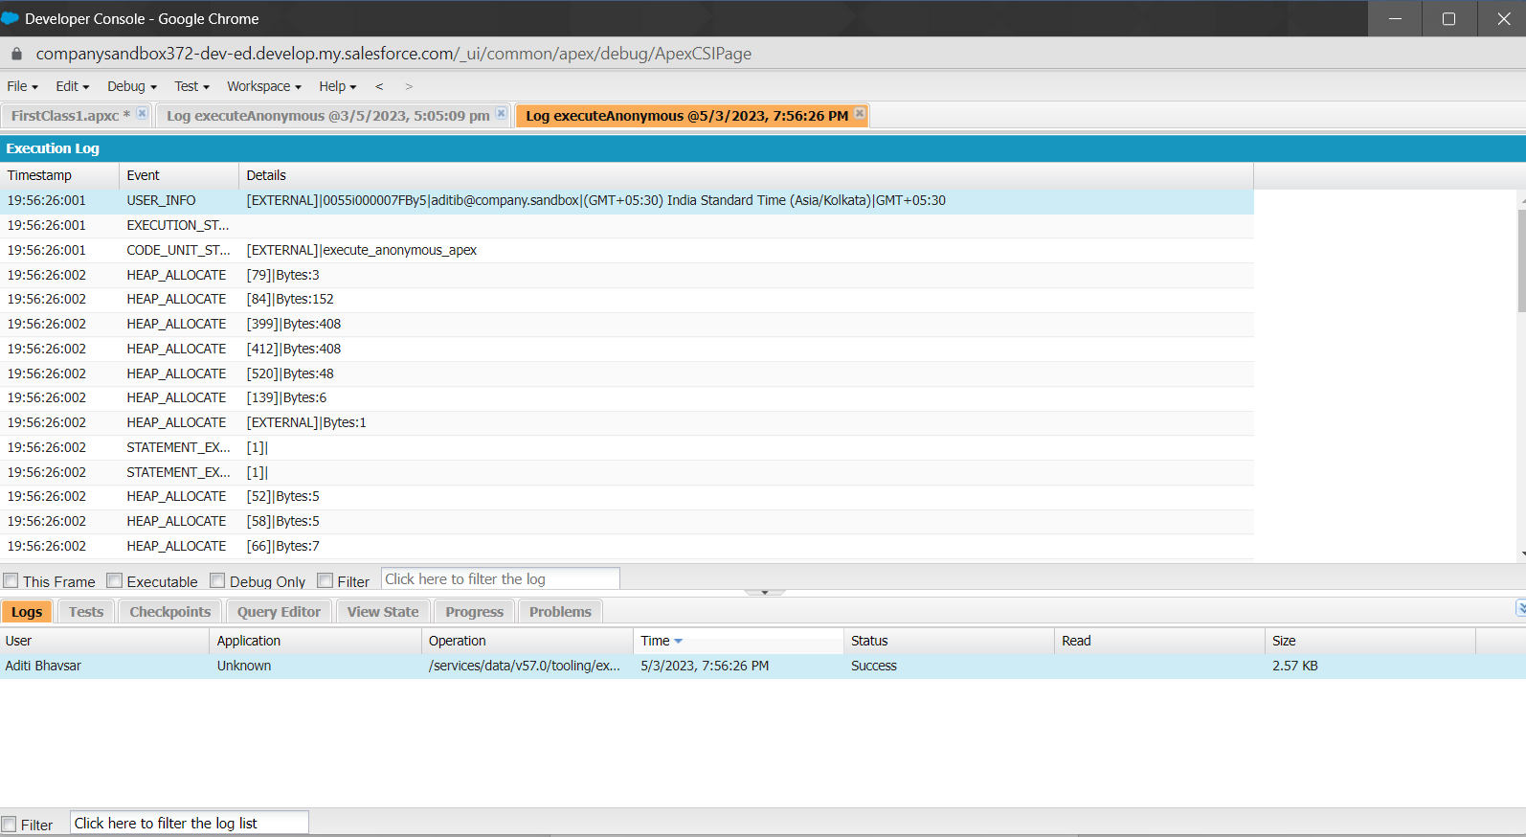

7. Click on Debug only (You will get output)

